**Use Cases & Activity Diagrams**

**Use Case Diagram**

Insert Here

**Use Cases**

1. Log into the application

Primary Actor:

* User

Goal in Context:

* To log into the application

Preconditions:

1. User has created an account
2. User knows their account information

Trigger:

* User wants to log into the application

Scenario:

1. User opens application
2. User inputs username or email into username/email field
3. User inputs password into password field
4. User clicks login
5. Application verified credentials
6. User is logged into the application

Alternatives:

* Step 5
  + The user’s credentials are not found in the system. The input fields are cleared, and the user is prompted for credentials again

Exceptions:

1. The user does not have an account. Follow either “Create an Interpreter Account” or “Create a Job Poster Account” use case to resolve.

Activity Diagram

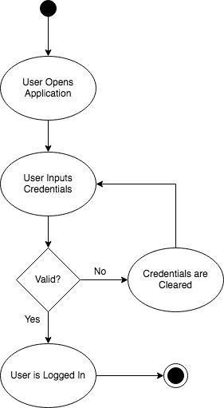

1. Create an Interpreter Account

Primary Actor:

* Interpreter

Goal in Context:

* Create an account for an Interpreter

Preconditions:

1. Interpreter has an ID
2. Interpreter has a valid email and phone number

Trigger:

* Interpreter wants to create an account

Scenario:

1. Interpreter opens application
2. Interpreter clicks on “Create Account” button
3. Interpreter selects “I am an Interpreter”
4. Interpreter fills in required fields
5. Interpreter clicks “Submit”
6. Application verifies information is in correct format
7. Application creates Interpreter account
8. Application takes Interpreter back to Login Screen

Alternatives:

* Step 4
  + The middle name field is optional and can be left blank
* Step 6
  + If the password does not contain at least one capital letter and one number, the field is cleared, and the Interpreter is informed of what the password needs
  + If the phone number does not contain 10 numbers, the field if cleared, and the Interpreter is informed that a valid phone number is required
  + If any input is too long, the input is cleared, and the Interpreter is informed that a shorter entry is required

Exceptions:

1. The Interpreter does not have an ID number. They will not be able to create an account
2. The Interpreter does not have a valid phone and email. They will not be able to create an account

Activity Diagram

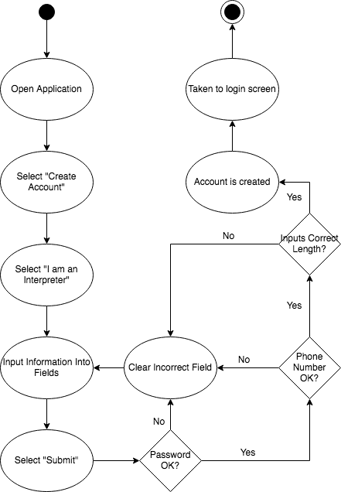

1. Create a Job Poster Account

Primary Actor:

* Job Poster

Goal in Context:

* Create an account for a Job Poster

Preconditions:

1. Job Poster has a valid email and phone number

Trigger:

* Job Poster wants to create an account

Scenario:

1. Job Poster opens application
2. Job Poster clicks on “Create Account” button
3. Job Poster selects “I am looking for interpreting services”
4. Job Poster fills in required fields
5. Job Poster clicks “Submit”
6. Application verifies information is in correct format
7. Application creates Job Poster account
8. Application takes Job Poster back to Login Screen

Alternatives:

* Step 4
  + The middle name field is optional and can be left blank
* Step 6
  + If the password does not contain at least one capital letter and one number, the field is cleared, and the Job Poster is informed of what the password needs
  + If the phone number does not contain 10 numbers, the field if cleared, and the Job Poster is informed that a valid phone number is required
  + If any input is too long, the input is cleared, and the Job Poster is informed that a shorter entry is required

Exceptions:

1. The interpreter does not have an ID number. They will not be able to create an account

Activity Diagram

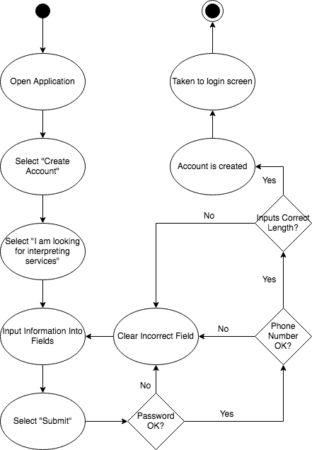

1. Post a Job to the Job Board

Primary Actor:

* Job Poster

Goal in Context:

* Post a job to the job board

Preconditions:

1. Job Poster has the correct information for posting
2. Job Poster is logged into the application

Trigger:

* Job Poster wants to post a job to the application

Scenario:

1. Job Poster is at the main menu
2. Job Poster clicks on “Post Job” button
3. Job Poster is taken to Job Creation Screen
4. Job Poster fills in address of the location of the job and the time and date it will occur at
5. Job Poster inputs LEP number, claim number, and selects what agency will be paying
6. Job Poster will fill in the general description of the job and select the language that is needed for the interpretation job
7. The System verifies that all information meets standards for input into the database
8. Once verified the Job Poster is shown the information and is able to edit if any is incorrect
9. Once the information if verified the Job Poster can click “Post” to submit the job and post it to the application
10. The Job Poster is taken back to the home screen

Alternatives:

* Step 7
  + As each window is completed the system will verify that information. If not, then the field will be cleared, and the Job Poster will be prompted to fill in the field with valid data
* Step 9
  + From here the Job Poster can click on “Post Another” to immediately post another job without going back to the home screen

Exceptions:

1. If the Job Poster does not have the LEP number or claim number, then a job posting cannot be made
2. If the start time is made before the existing date or the times do not work logically then the user will need to edit them so that they work

Activity Diagram

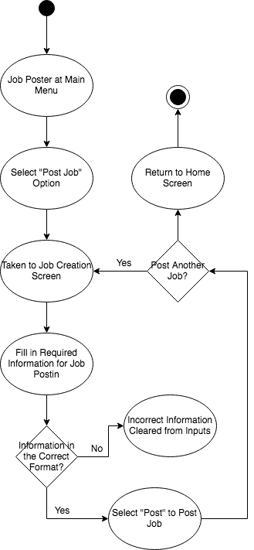

1. Pick Up a Job from the Job Board

Primary Actor:

* Interpreter

Goal in Context:

* To select a job from posted job and assign it to the interpreter

Preconditions:

* Interpreter is logged into the application
* Interpreter wants to pick up a job

Trigger:

* Interpreter is looking for a job

Scenario:

1. Interpreter is at the main menu
2. Interpreter clicks on the “Search for Job” button
3. Interpreter selects the date, language, and start time to search by from drop down menu
4. System displays relevant jobs to the interpreter
5. Interpreter clicks on a job they want
6. System displays further details about the job
7. System displays new window with job details
8. Interpreter clicks on the “Select Job” button
9. System adds the job to the interpreters list of taken jobs and generates a work order
10. Interpreter clicks the “Main Menu” button
11. System returns to the main menu

Alternatives:

* Step 3
  + If a job is not found, the Interpreter can change the search criteria to try and find more results
* Step 10
  + Interpreter can click on another job and continue from step 5 to continue looking at jobs

Exceptions:

1. If an interpreter attempts to add a Job that they have already taken, then the system will not add a duplicate and the window displaying the job information will be close

Activity Diagram

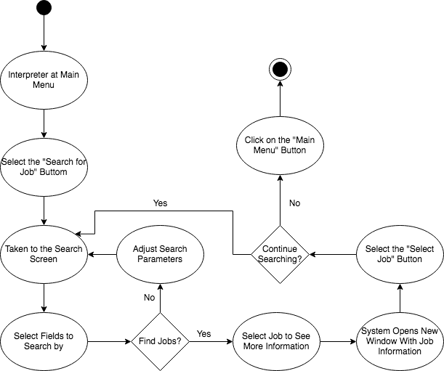

1. Review All Posted Jobs

Primary Actor:

* Job Poster

Goal in Context:

* See all posted jobs from one Job Poster

Preconditions:

* Job Poster is logged into the application
* Job Poster has jobs posted that are currently active

Trigger:

* A Job Poster wants to see all of their currently active jobs

Scenario:

1. Job poster is at main menu
2. Job poster clicks on “My Jobs” button
3. System displays list of currently active jobs to screen
4. Job poster clicks on job to show information in new window
5. Job poster clicks “Close” button
6. Job poster clicks on “Main Menu” button to return

Alternatives:

* Step 5
  + Job Poster can click on another job to see information about another job instead of going back to main menu

Exceptions:

1. Nothing will be displayed if Job Poster has either not posted any jobs, or if they have no active jobs

Activity Diagram

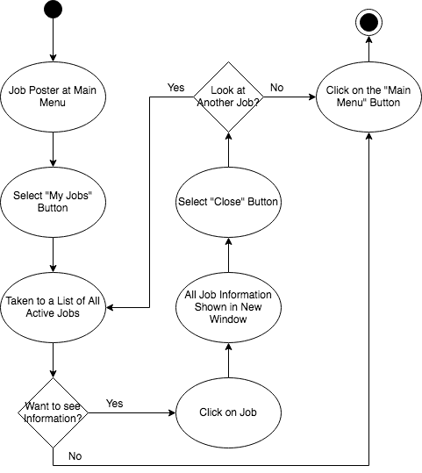

1. Review All Picked Up Jobs
2. Delete a Posted Job
3. Update a Posted Job
4. Delete a Picked-Up Job
5. Update Profile Information
6. Review Invoices
7. Update Work Order
8. Update Invoice
9. Log out